**32X128pixel RGB indoor led sign**

1. Mobile phone APP download:

<http://www.xy1701.com/en/download/download-70-737.html>

1. PC APP download:

<http://www.xy1701.com/en/download/download-57-565.html>

**Operation:**

1. Find WIFI with beginning of “TF-QB030”(each led sign WIFI name is different”,click and input password 88888888.
2. When open software,click “Tools” and choose “Panel Setup”,input password “168”,

Then click “Screen Setup”,choose color as RGB,width “128”,height “32”,click “Setup”.

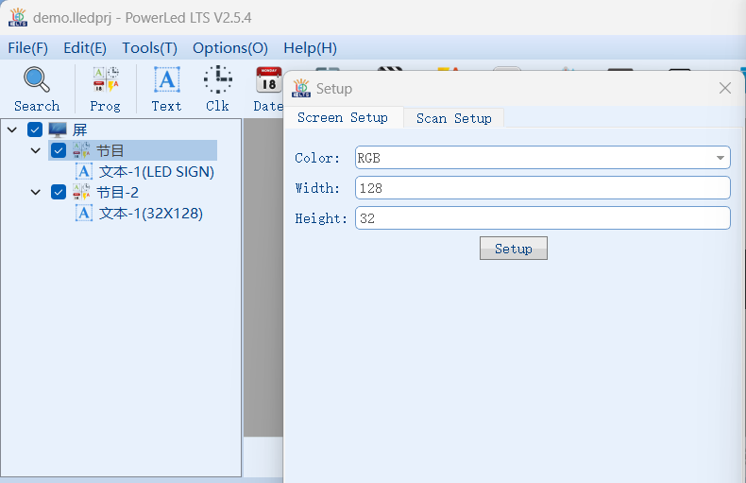

3.After above,then you can compile your own message in software.